

|  |
| --- |
| **ADEWUNMI ADELEYE** April 2023. MySQL Task |
| AA |

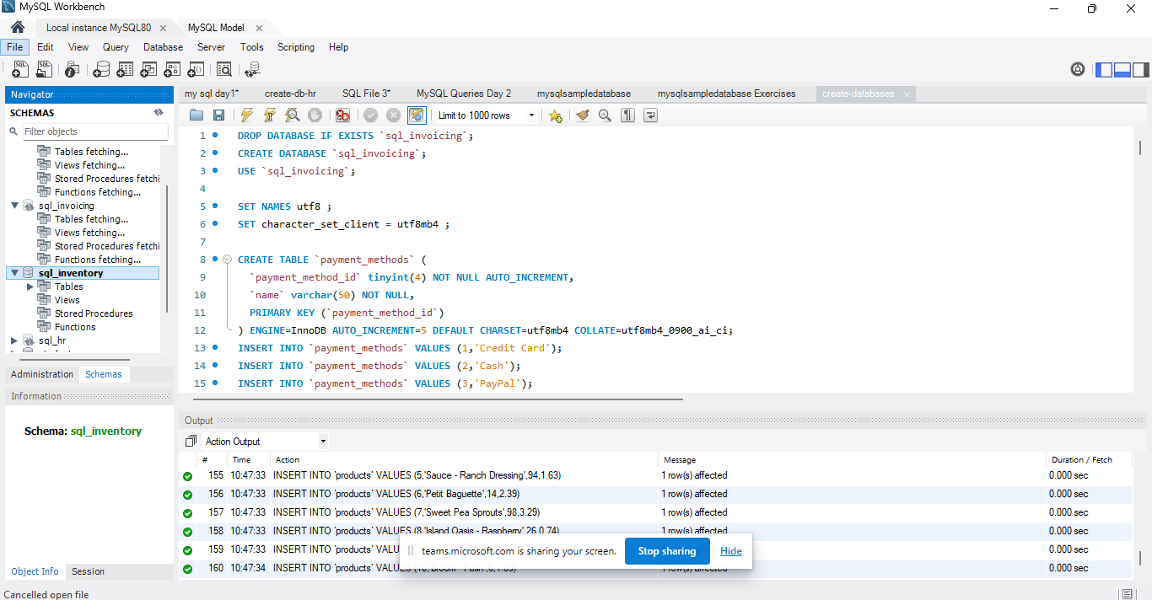Importing databases SQL script into MySQL Workbench. Running the script and creating databases.



Inputting the following into the file Query 1 and adding the original point and the points plus 10.

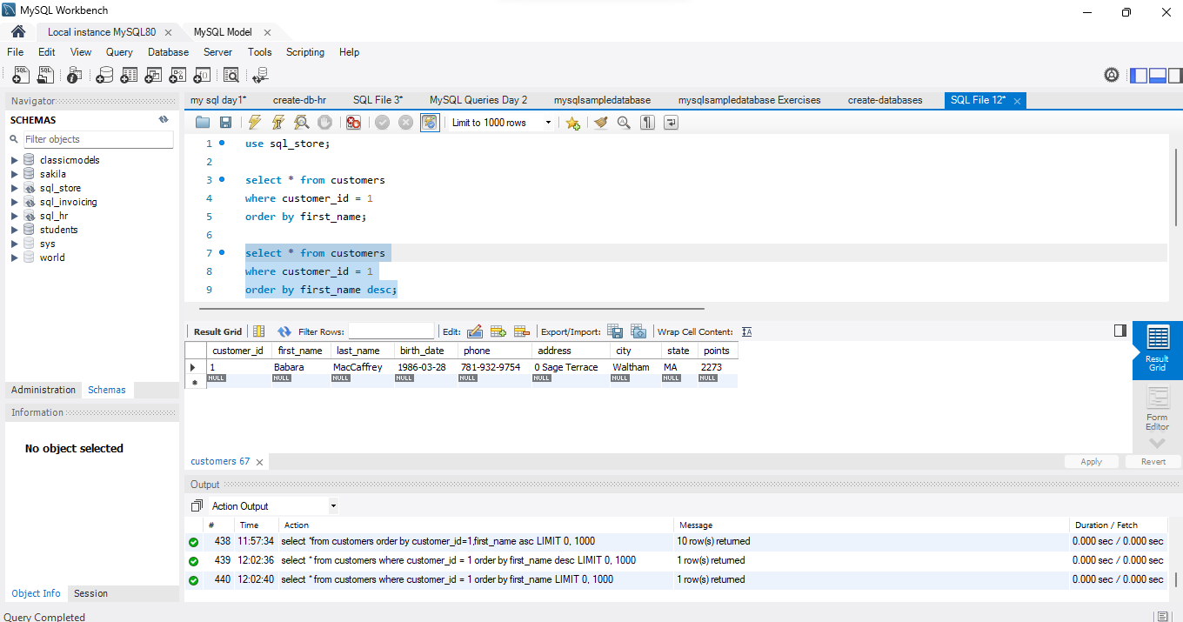



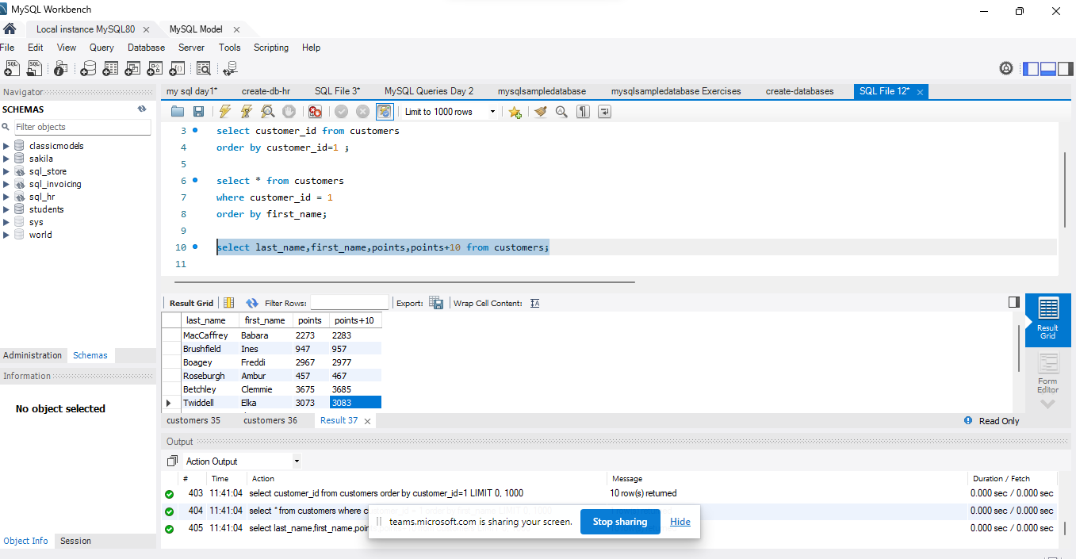



Using the Query 2 you created change the points to reads times by 10 and plus 100.

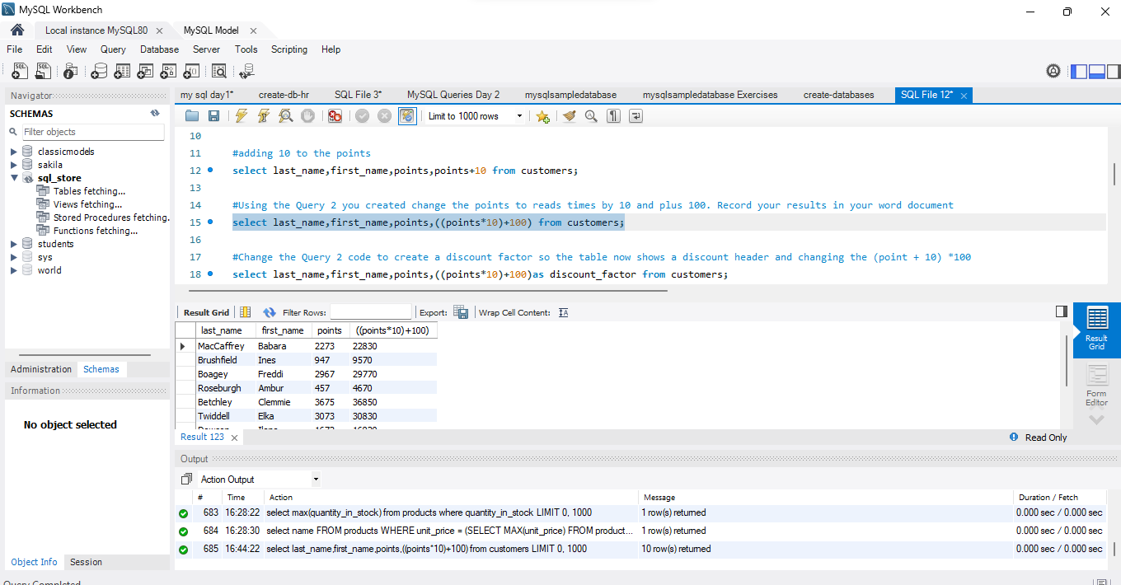



Changing the Query 2 code to create a discount factor so the table now shows a discount header and changing the (point + 10) *100.

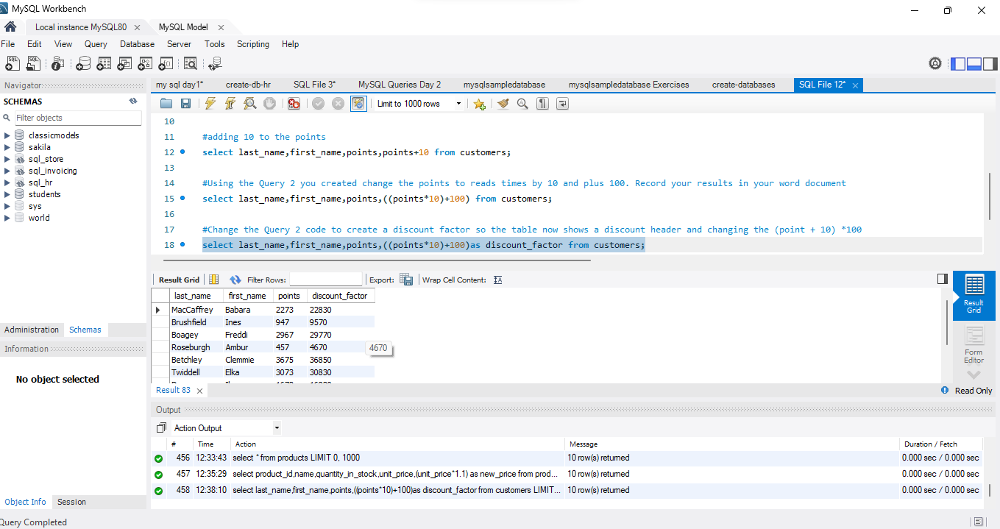



Increasing the product price of each by 10%. Showing columns; name, unit price, and new column called new price which is based on this expression, (unit price * 1.1 ).

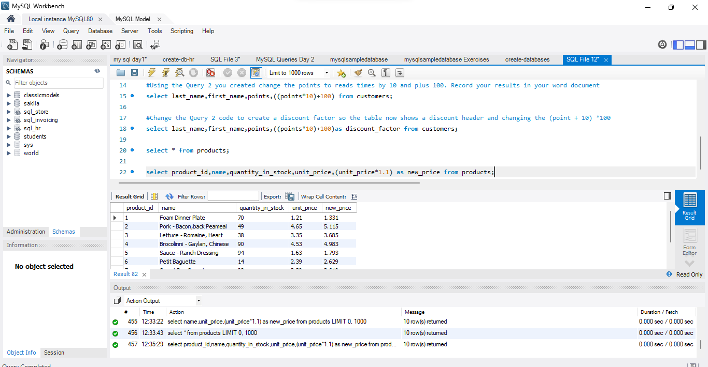



In this task, creating a new query to find all the customers with a birth date of > '1990-01-01'

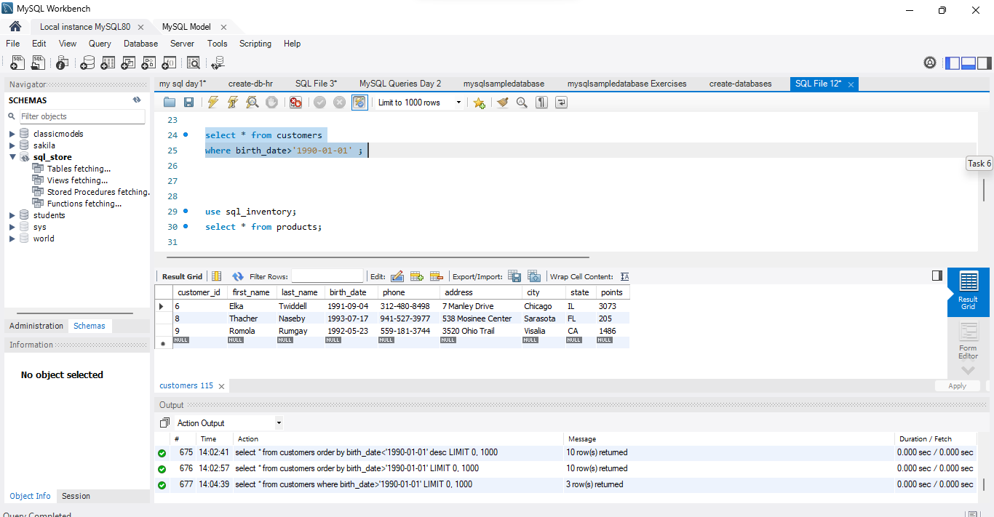



Writing a query to find out the name of the product with most amount in stock.

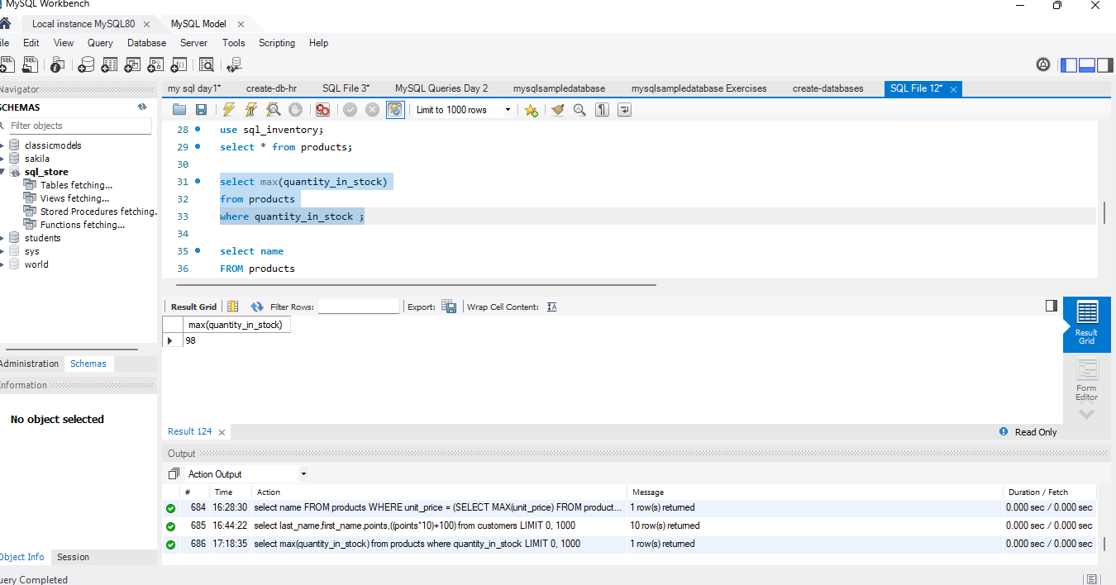



Writing a query to find out the name of the most expensive product.

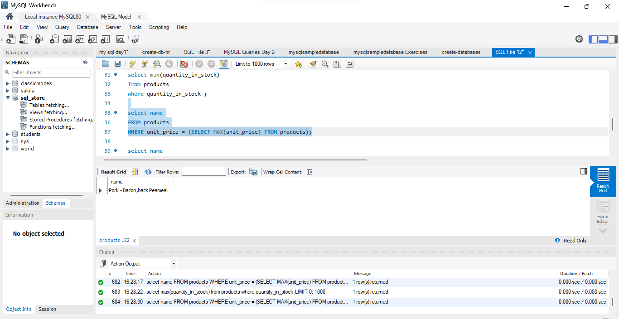



Write a query to find out the first name, last name, address and the birthdate of the oldest customer.

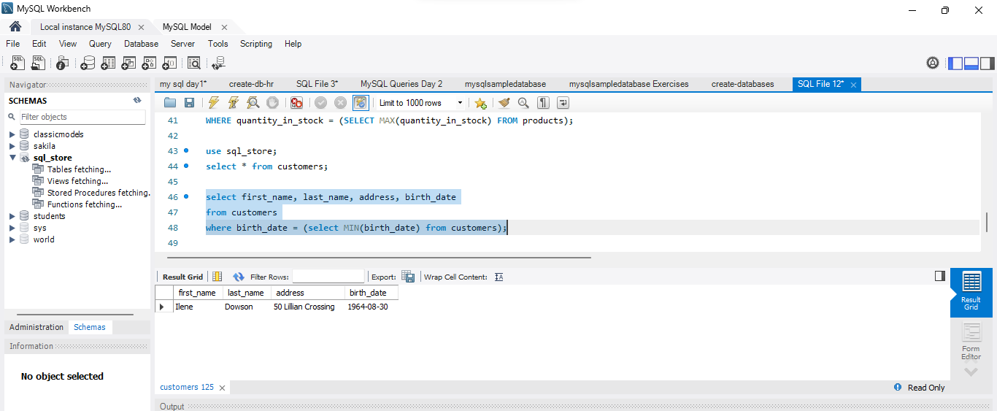



**CREATING AN EER (Enhanced Entity-Relationship) DIAGRAM**

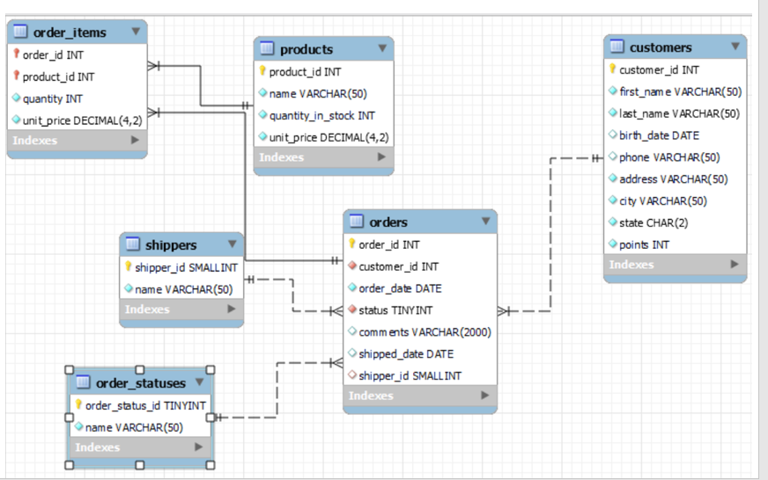

TASK 6: Select sql_store. Write a query to find out the first name, last name, address and the birthdate of the oldest customer.

